Did you know?
The White House Identifies Plumbers as 'Essential Critical Infrastructure Workers'!
Northern Nevada
PHCC-NV Training Center
c/o HTA Plumbing
700 Bennie Lane
Reno, NV 89512
Wednesdays 1pm – 4pm
Southern Nevada
PHCC-NV Howard T. Arata Training Center
252 Sunpac Ave.
Henderson, NV 89011
Wednesday, & Thursday 11am - 3pm
By appointment only
CHARACTERISTICS OF THE TRADE:
Apprentices shall be under the supervision of a qualified journeyperson plumber. The trade requires physical effort on the part of the apprentice to undergo climbing, crawling, pulling, lifting, crouching, and working in cramped quarters. Mechanical ability and finger dexterity are essential. Depending on the job, the work may be performed either indoors or outdoors, with the major portion of the work outdoors in semi-sheltered or unfinished buildings or in deep ditches and on scaffolding.

LENGTH OF APPRENTICESHIP:
The term of apprenticeship for this trade is four (4) years of on-the-job training, which shall include four (4) years of night school. In-person attendance is mandatory; classes take place two (2) evenings per week as mandated by the PHCC-NV Education Foundation.

MINIMUM REQUIREMENTS:
- Age: Must be at least 17 years of age at time of application and 18 years of age at time of selection.
- Birth Certificate required.
- Education: Possess a High School Diploma, G.E.D. certificate, or High School Equivalency (HSE).*
- Aptitude: Must successfully complete a basic aptitude exam.
  - Oral Interview: Must successfully complete an oral interview administered by the PHCC-NV Education Foundation.
- Physical: Applicants must be of such physical condition as to not place self or future co-workers in jeopardy.
- Random Drug Testing: Negative test results on an annual basis.
- Transportation: Must have reliable personal transportation.

US Military Veterans: Our program is approved for the use of VA Education Benefits. *Dependent on eligibility.*

HOW TO APPLY:
Call to make an appointment to apply in person at the above-listed locations. Applicants must complete a basic aptitude exam at the time of application.

*Please note: Applicants must have all the required documents before receiving an application.*
If you are unable to provide any of the required documents or fulfill any of the minimum requirements, contact the PHCC-NV office at (702) 252-0166 to discuss your options.

Please provide copies of the following documents at the time of application:
- Birth Certificate
- High School Diploma, G.E.D., or HSE
- Social Security Card
See page 2 for more information.
- Valid Nevada picture I.D.
- Military DD-214 Release Papers & Military Transcripts (if applicable)
- Documentation of references and/or experience (if applicable)
- Documentation of experience with an accredited training program (if applicable)
INTERVIEW INFORMATION:
Applicants will be interviewed, in person, on Wednesday February 18, 2026. Interviews will be conducted by the Joint Apprenticeship Training Committee. Failure to appear for the oral interview will constitute just cause to void the application.

SELECTION:
Applicants will be placed on a “Ranking List” according to their scores at the evaluation session, with the applicant having the highest score being at the top of the list, and all applicants then listed descending order based on score.

Applicants that complete the PHCC Academy Plumbing & HVAC Workforce Readiness Course (free) and the PHCC Academy Plumbing Pre-Apprentice Course ($29) will receive extra points on their selection score. The course fee is non-refundable & non-reimbursable by the PHCC-NV. The PHCC-NV office must receive the course completion certificates by the time of the interview. Use the below links/QR codes to access the courses.
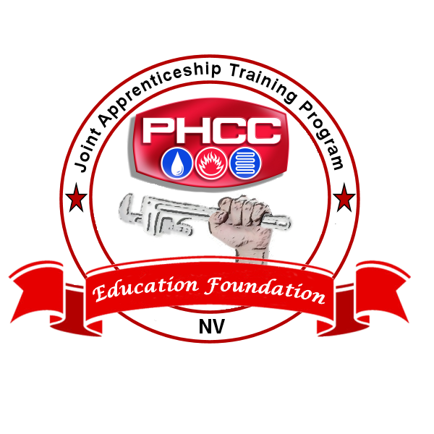
PHCC Academy Plumbing Workforce Readiness Course (Free)
https://bit.ly/PHCCWFR



PHCC Academy Plumbing Pre-Apprentice Course ($29)
https://bit.ly/PlbPreApp
